ALWAYS-ON CONTENT ENGINE | PERSONAL ACCOUNT
Stay active. Let new people find you and ZYKL.
Four weeks of posts, one a day, in English and Bahasa Indonesia: 28 captions, 11 images, 3 polls. Each day has a theme, so you never face a blank page. Every caption fits Threads' 500-character limit.

1. What your latest screenshot says
Post | What you showed | How to read it
'200+ replies on a one-line hello' | Your thank-you post, 11h old at the time | Gratitude and conversation keep the hello post alive. Keep thanking people in public.
The tester call (12+ Android testers) | 5h old: 1 like, 2 replies, 1 repost, 1 share | A direct ask moves slower than a conversation. That's normal, and it's why asks need company.
'Developer to Developer' and the hello post earlier | 1-2 replies versus 200+ replies | Open invitations beat narrow questions. Most days should feel like an invitation to talk.
Readings from three data points, not certainties. Check Insights before you rely on them.

The 4-to-1 rule
For every direct ask (a tester call), post about four things that give something away: a tip, a story, a question, a detail. The plan below does that: only the Sunday posts ask, and they ask gently.

2. The weekly rhythm
Day | Theme | What it does for you
Mon | Build in public | Proof that the product is real and moving.
Tue | Focus tip | Useful and save-worthy, so strangers follow you for it.
Wed | Builder question | Starts conversations. This is your hello-post format.
Thu | Design detail | Shows the craft behind ZYKL without selling.
Fri | Founder story | Lets people get to know you.
Sat | Light and fun | Polls and easy questions keep the account warm.
Sun | Gentle ask | The only post that asks for something, in a calm tone.

3. The 15-minute daily routine
- Post the day's caption (2 minutes). Attach the image or set up the poll.
- Stay for 10 minutes and reply to every comment on your own post. This is what grew the hello post.
- Leave 3 to 5 genuine comments on other people's posts in the solo-founder and app-maker topics. Add something useful, never a link to ZYKL.
- On busy days, post a fallback prompt from section 5 and skip the rest.

Weekly 5-minute review
Check | Where | Why
Which post got the most replies? | Insights | Do more of that theme next week.
New followers this week | Profile | Shows whether discovery is working.
Tester sign-ups and where they came from | Tester tracker (zykl-tester-tracker.xlsx) | Shows which posts bring testers.
Which Sunday ask worked best | Replies and sign-ups | Keep the tone that works.

4. The 28 posts
Highlighted text is a name or a number to fill in (there are none left in the captions). Images are in images/personal-active, plus two reused from images/personal. Posts that describe you are drafts: edit them until they're true.

Post 1: Build in public
TEXT ONLY | Week 1, Mon | Build in public | Text only  ENGLISH  Build log, week one of showing my work.  This week: 12+ testers wanted, a short video of the dial, and a lot of replies to read.  Next week: fix whatever testers find. Building in public means you see the boring parts too.  What would you like to see more of: progress, mistakes, or numbers?  BAHASA INDONESIA  Catatan build, minggu pertama memperlihatkan proses.  Minggu ini: cari 12+ penguji, video singkat dial, dan banyak balasan untuk dibaca.  Minggu depan: memperbaiki apa pun yang ditemukan penguji. Membangun di depan umum berarti kamu juga melihat bagian yang membosankan.  Kamu mau lihat lebih banyak apa: progres, kesalahan, atau angka?  TIP  Edit the 'this week' line so it matches your real week.  EN 291 / ID 336 characters (limit 500)

Post 2: Focus tip
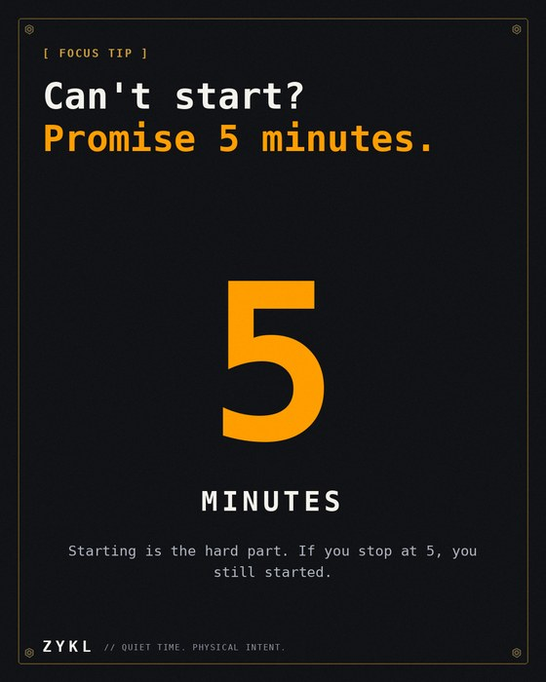  images/personal-active/en|id/w01_tip_start_small.png | Week 1, Tue | Focus tip | Text + image  ENGLISH  Focus tip: when you can't start, promise yourself 5 minutes.  Not 25. Not an hour. Just 5. Starting is the hard part, and most of the time you'll keep going.  If you stop at 5, that's fine. You still started.  What's your trick for starting?  BAHASA INDONESIA  Tips fokus: kalau susah mulai, janjikan dirimu 5 menit.  Bukan 25. Bukan satu jam. Cukup 5. Memulai adalah bagian tersulit, dan sering kali kamu akan lanjut sendiri.  Kalau berhenti di menit ke-5, tidak apa-apa. Kamu tetap sudah mulai.  Apa triknya untuk memulai?  TIP  Save-worthy tip. Great for new people who don't know you yet.  EN 241 / ID 263 characters (limit 500)

Post 3: Builder question
TEXT ONLY | Week 1, Wed | Builder question | Text only  ENGLISH  Builders: what was the smallest thing that made your product feel real?  For me it was the first time the dial clicked under my finger on a real phone, not in a design file.  One line is enough.  BAHASA INDONESIA  Para builder: apa hal terkecil yang membuat produkmu terasa nyata?  Buatku, saat dial pertama kali berbunyi klik di bawah jari di ponsel sungguhan, bukan di file desain.  Satu kalimat cukup.  TIP  Draft detail about you. Change it if your moment was different.  EN 194 / ID 190 characters (limit 500)

Post 4: Design detail
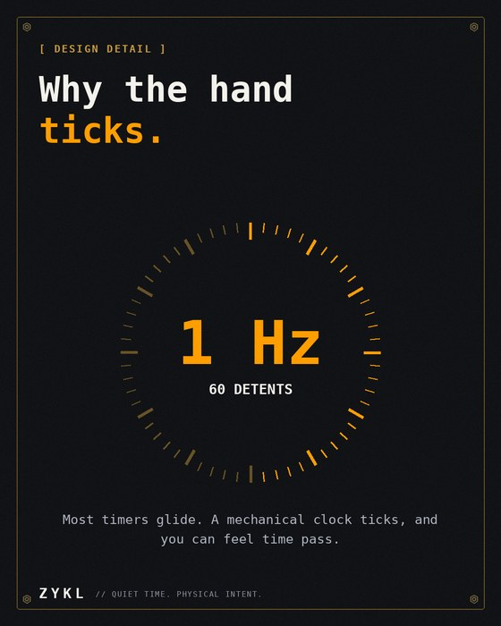  images/personal-active/en|id/w04_design_tick.png | Week 1, Thu | Design detail | Text + image  ENGLISH  Design detail: why the ZYKL hand ticks.  Most timers glide. A mechanical clock ticks with a tiny bounce every second, and you can feel time pass.  So ZYKL's hand ticks once a second, with a shadow that moves with it. Small, but it makes the dial feel like an object.  BAHASA INDONESIA  Detail desain: kenapa jarum ZYKL berdetak.  Kebanyakan timer meluncur mulus. Jam mekanik berdetak dengan hentakan kecil tiap detik, dan kamu bisa merasakan waktu berjalan.  Jadi jarum ZYKL berdetak sekali tiap detik, dengan bayangan yang ikut bergerak. Kecil, tapi membuat dial terasa seperti benda.  TIP  Source: changelog v1.0.0 (60 detents, 1 Hz). Pair with the 6-second dial clip if you like.  EN 266 / ID 299 characters (limit 500)

Post 5: Founder story
TEXT ONLY | Week 1, Fri | Founder story | Text only  ENGLISH  A rule I keep when building ZYKL: if a feature needs a tutorial, I redesign it.  The dial doesn't need one. You turn the hand. The slip doesn't need one. You stamp it. That's the bar.  What's a product that never needed a manual?  BAHASA INDONESIA  Aturan yang kupegang saat membuat ZYKL: kalau sebuah fitur butuh tutorial, aku desain ulang.  Dial tidak butuh tutorial. Kamu putar jarumnya. Slip tidak butuh tutorial. Kamu cap. Itu standarnya.  Produk apa yang tidak pernah butuh buku panduan?  TIP  A principle drafted for you. Keep it only if it's true to how you work.  EN 229 / ID 244 characters (limit 500)

Post 6: Light and fun
POLL | Week 1, Sat | Light and fun | Text + poll  ENGLISH  Saturday poll: how do you start a focus session?  Vote below. No wrong answers.  BAHASA INDONESIA  Poll Sabtu: bagaimana kamu memulai sesi fokus?  Vote di bawah. Tidak ada jawaban salah.  POLL OPTIONS (25 CHARACTERS MAX EACH)  EN: Coffee first / Phone away / Playlist on / Just start  ID: Kopi dulu / HP disingkirkan / Putar playlist / Langsung mulai  TIP  Use the built-in poll. Share the result next Saturday.  EN 79 / ID 87 characters (limit 500)

Post 7: Gentle ask
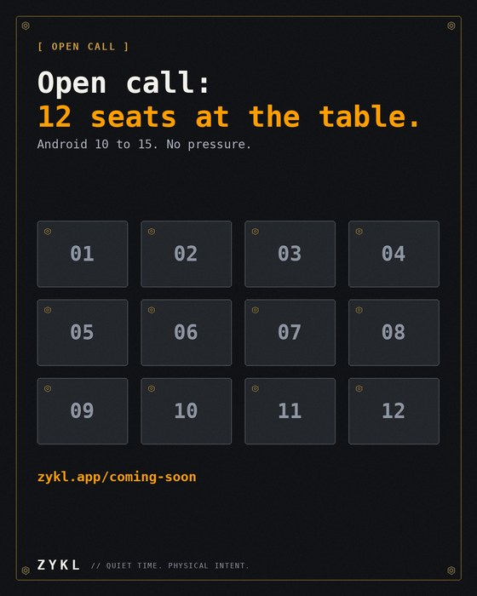  images/personal-active/en|id/w06_open_call_seats.png | Week 1, Sun | Gentle ask | Text + image  ENGLISH  Open call: 12 seats at the testing table.  I'm building ZYKL, a calm focus timer for Android, and I'm looking for people to try it before it reaches Google Play.  If that sounds like fun, you're very welcome. If not, no worries at all. Sharing this with a friend helps just as much.  zykl.app/coming-soon  BAHASA INDONESIA  Open call: 12 kursi di meja uji.  Aku sedang membuat ZYKL, timer fokus yang tenang untuk Android, dan mencari orang yang mau mencobanya sebelum rilis di Google Play.  Kalau terdengar seru, kamu sangat diterima. Kalau belum, tidak apa-apa sama sekali. Membagikannya ke teman juga sangat membantu.  zykl.app/coming-soon  TIP  Post only while spots are open. This is the gentle ask for the week.  EN 304 / ID 317 characters (limit 500)

Post 8: Build in public
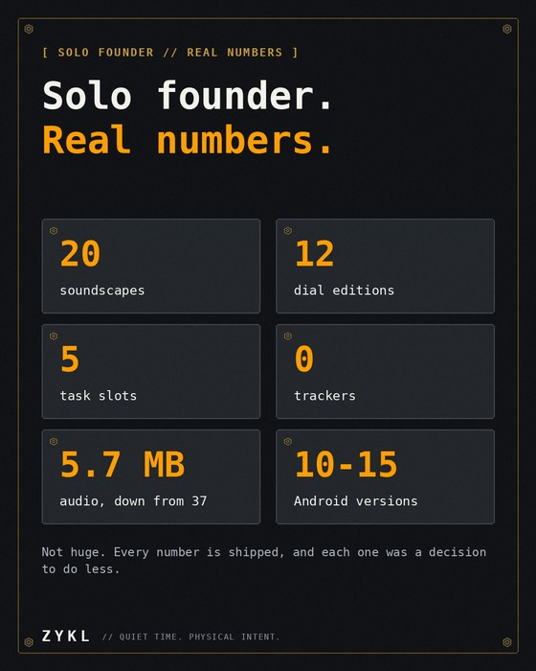  images/personal/en|id/p04_numbers.png | Week 2, Mon | Build in public | Text + image  ENGLISH  ZYKL today, in numbers:  20 real-recording soundscapes  12 dial editions  5 task slots  0 trackers, 0 ads  Solo-built, and still in early beta. Every number is a decision to do less.  Which one surprises you?  BAHASA INDONESIA  ZYKL hari ini, dalam angka:  20 suara latar dari rekaman asli  12 edisi dial  5 slot tugas  0 pelacak, 0 iklan  Dibuat sendirian, dan masih beta awal. Setiap angka adalah keputusan untuk mengerjakan lebih sedikit.  Mana yang paling mengejutkanmu?  TIP  Reuses the 'real numbers' image from your personal bank.  EN 205 / ID 243 characters (limit 500)

Post 9: Focus tip
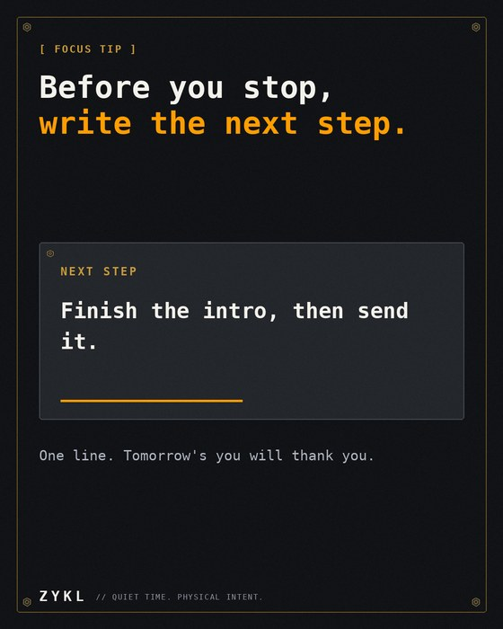  images/personal-active/en|id/w02_tip_next_step.png | Week 2, Tue | Focus tip | Text + image  ENGLISH  Focus tip: before you stop working, write down the very next step.  One line. Tomorrow's you won't spend 15 minutes remembering where you were.  The best end to a session is a note to the next one.  Do you do this already?  BAHASA INDONESIA  Tips fokus: sebelum berhenti bekerja, tulis langkah berikutnya.  Satu baris saja. Dirimu besok tidak perlu 15 menit mengingat tadi sampai mana.  Akhir sesi terbaik adalah catatan untuk sesi berikutnya.  Kamu sudah melakukannya?  TIP  Save-worthy tip.  EN 222 / ID 227 characters (limit 500)

Post 10: Builder question
TEXT ONLY | Week 2, Wed | Builder question | Text only  ENGLISH  Solo builders: how do you decide what NOT to build?  My filter is simple: will someone miss it on day one? If not, it waits.  Curious what yours is.  BAHASA INDONESIA  Solo builder: bagaimana kamu memutuskan apa yang TIDAK dibuat?  Filterku sederhana: apakah ada yang merasa kehilangan di hari pertama? Kalau tidak, ditunda.  Penasaran apa filtermu.  TIP  Draft filter. Replace it with yours if it differs.  EN 148 / ID 181 characters (limit 500)

Post 11: Design detail
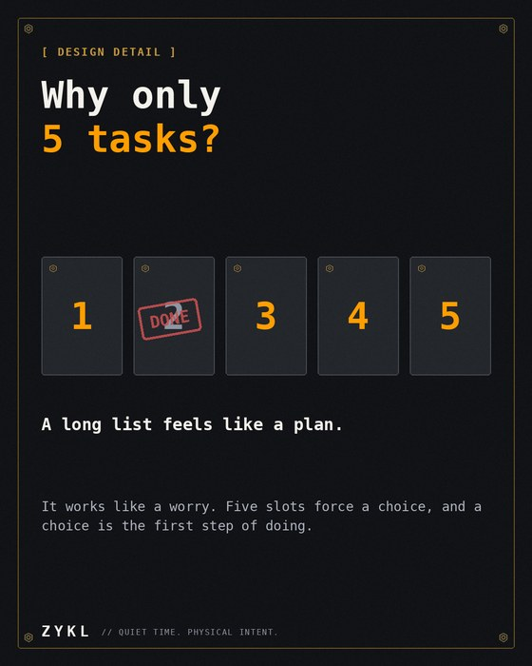  images/personal-active/en|id/w05_design_five_slots.png | Week 2, Thu | Design detail | Text + image  ENGLISH  Design detail: why ZYKL's slip holds only 5 tasks.  A long list feels like a plan but works like a worry. Five slots force a choice, and a choice is the first step of doing.  Full? Stamp one done, or tear it off and start clean.  BAHASA INDONESIA  Detail desain: kenapa slip ZYKL hanya memuat 5 tugas.  Daftar panjang terasa seperti rencana tapi bekerja seperti kekhawatiran. Lima slot memaksa kita memilih, dan memilih adalah langkah pertama untuk melakukan.  Penuh? Cap satu selesai, atau sobek dan mulai bersih.  TIP  Ties back to the '5 tasks, not 38' idea in your other posts.  EN 228 / ID 266 characters (limit 500)

Post 12: Founder story
TEXT ONLY | Week 2, Fri | Founder story | Text only  ENGLISH  Building alone is quiet. Nobody tells you whether the idea is good, so you learn to read small signals instead: one reply, one stranger who gets it.  This month a one-line hello reached more people than my careful posts. The lesson: say who you are, and let people talk.  What small signal kept you going?  BAHASA INDONESIA  Membangun sendirian itu sepi. Tidak ada yang bilang idemu bagus atau tidak, jadi kamu belajar membaca sinyal kecil: satu balasan, satu orang asing yang paham.  Bulan ini satu postingan hai menjangkau lebih banyak orang daripada postingan-postinganku yang disusun hati-hati. Pelajarannya: bilang siapa dirimu, dan biarkan orang bicara.  Sinyal kecil apa yang membuatmu terus jalan?  TIP  Your own experience, so it should feel true when you read it.  EN 305 / ID 380 characters (limit 500)

Post 13: Light and fun
POLL | Week 2, Sat | Light and fun | Text + poll  ENGLISH  This or that: analog clock or digital clock on your desk?  I know which I picked for ZYKL. Tell me yours.  BAHASA INDONESIA  Pilih salah satu: jam analog atau jam digital di mejamu?  Aku tahu mana yang kupilih untuk ZYKL. Sekarang jawabanmu.  POLL OPTIONS (25 CHARACTERS MAX EACH)  EN: Analog / Digital  ID: Analog / Digital  TIP  Reveal the result with a 'told you so' in the replies.  EN 105 / ID 116 characters (limit 500)

Post 14: Gentle ask
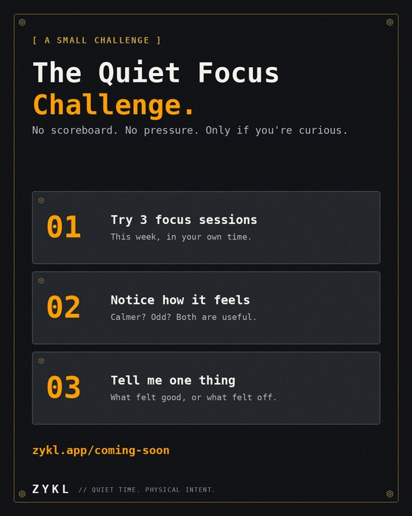  images/personal-active/en|id/w07_quiet_challenge.png | Week 2, Sun | Gentle ask | Text + image  ENGLISH  A small challenge, if you're up for it: the Quiet Focus Challenge.  Try 3 focus sessions with ZYKL this week. Notice how it feels. Then tell me one thing that felt good or off.  There's no scoreboard and no pressure. Just a calmer way to work, and honest feedback for me.  Join the beta: zykl.app/coming-soon  BAHASA INDONESIA  Tantangan kecil, kalau kamu mau: Tantangan Fokus Tenang.  Coba 3 sesi fokus dengan ZYKL minggu ini. Perhatikan rasanya. Lalu kabari aku satu hal yang terasa enak atau janggal.  Tidak ada papan skor dan tidak ada tekanan. Hanya cara kerja yang lebih tenang, dan masukan jujur untukku.  Gabung beta: zykl.app/coming-soon  TIP  A 'sayembara' feel without a prize. If you decide to offer a perk, see the optional lines in section 6.  EN 308 / ID 318 characters (limit 500)

Post 15: Build in public
TEXT ONLY | Week 3, Mon | Build in public | Text only  ENGLISH  How a focus timer keeps counting when the screen is off:  ZYKL uses a foreground service and on-time alarms, so the dial stays honest even if Android wants to save battery.  Boring plumbing, but it's the difference between a timer you trust and one you babysit.  Android devs: what's your favorite background-work gotcha?  BAHASA INDONESIA  Bagaimana timer fokus tetap menghitung saat layar mati:  ZYKL memakai foreground service dan alarm tepat waktu, jadi dial tetap jujur meski Android ingin menghemat baterai.  Plumbing yang membosankan, tapi itulah beda timer yang kamu percaya dan timer yang harus kamu awasi.  Dev Android: jebakan background work apa yang paling kamu ingat?  TIP  Source: your FAQ. A developer-facing post, good for the builders who found you.  EN 321 / ID 340 characters (limit 500)

Post 16: Focus tip
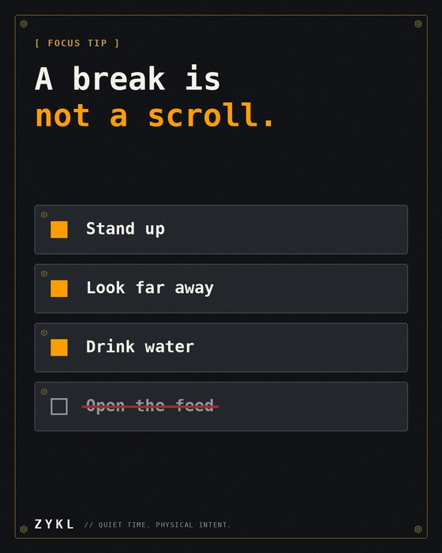  images/personal-active/en|id/w03_tip_rest.png | Week 3, Tue | Focus tip | Text + image  ENGLISH  Focus tip: a break is not a scroll.  Stand up, look far away, drink water. If you grab your phone, the break isn't a break, and your next session starts tired.  How do you spend your 5 minutes?  BAHASA INDONESIA  Tips fokus: istirahat bukan waktunya scroll.  Berdiri, lihat jauh, minum air. Kalau kamu meraih ponsel, istirahatnya bukan istirahat, dan sesi berikutnya dimulai dengan lelah.  Bagaimana kamu menghabiskan 5 menitmu?  TIP  Save-worthy tip.  EN 193 / ID 215 characters (limit 500)

Post 17: Builder question
TEXT ONLY | Week 3, Wed | Builder question | Text only  ENGLISH  What's one app you use daily that you'd happily pay once for, but refuse to subscribe to?  I'll start: a good timer. Yours?  BAHASA INDONESIA  Satu aplikasi yang kamu pakai tiap hari yang rela kamu bayar sekali, tapi tidak mau kamu langgani?  Aku mulai: timer yang bagus. Kalau kamu?  TIP  Seeds your one-time-purchase message without selling.  EN 123 / ID 140 characters (limit 500)

Post 18: Design detail
TEXT ONLY | Week 3, Thu | Design detail | Text only  ENGLISH  Design detail: why ZYKL's soundscapes are real recordings.  Rain on glass, a quiet library, bamboo in Kyoto. Real sound has tiny irregularities your ear stops noticing, which is exactly what you want while focusing.  20 of them, gapless and click-free. 8 are free.  BAHASA INDONESIA  Detail desain: kenapa suara latar ZYKL adalah rekaman asli.  Hujan di kaca, ruang baca yang sepi, bambu di Kyoto. Suara nyata punya ketidakteraturan kecil yang akhirnya tidak lagi kamu sadari, dan itu persis yang dibutuhkan saat fokus.  20 suara, mulus tanpa jeda dan klik. 8 gratis.  TIP  Pair with a short audio clip of rain if you can.  EN 264 / ID 283 characters (limit 500)

Post 19: Founder story
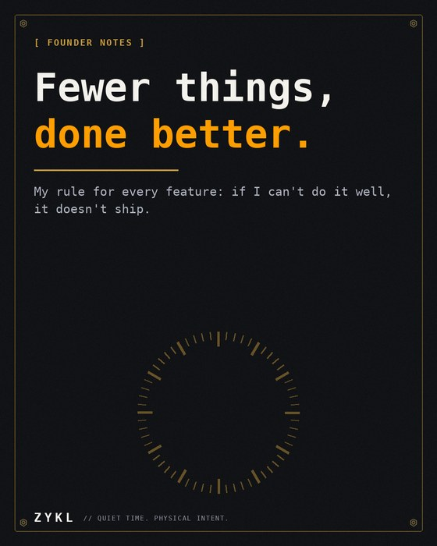  images/personal/en|id/p06_fewer_things.png | Week 3, Fri | Founder story | Text + image  ENGLISH  Fewer things, done better.  It's the line in my bio and the filter for every decision: features, colors, even how many tasks fit on a slip.  It's slower at first and faster forever. What's your equivalent of this line?  BAHASA INDONESIA  Sedikit hal, dikerjakan lebih baik.  Itu kalimat di bio-ku dan filter untuk setiap keputusan: fitur, warna, bahkan berapa tugas yang muat di satu slip.  Awalnya lebih lambat, selanjutnya selalu lebih cepat. Apa padanan kalimat ini bagimu?  TIP  Reuses the 'Fewer things' image from your personal bank.  EN 218 / ID 238 characters (limit 500)

Post 20: Light and fun
TEXT ONLY | Week 3, Sat | Light and fun | Text only  ENGLISH  Weekend question: what's the most satisfying sound you know?  For me it's a mechanical click: a dial, a switch, a stamp. No wrong answers, just good sounds.  BAHASA INDONESIA  Pertanyaan akhir pekan: suara paling memuaskan yang kamu tahu?  Buatku klik mekanis: dial, saklar, stempel. Tidak ada jawaban salah, hanya suara yang enak.  TIP  Light, easy to answer, and it points at the product's sound.  EN 156 / ID 155 characters (limit 500)

Post 21: Gentle ask
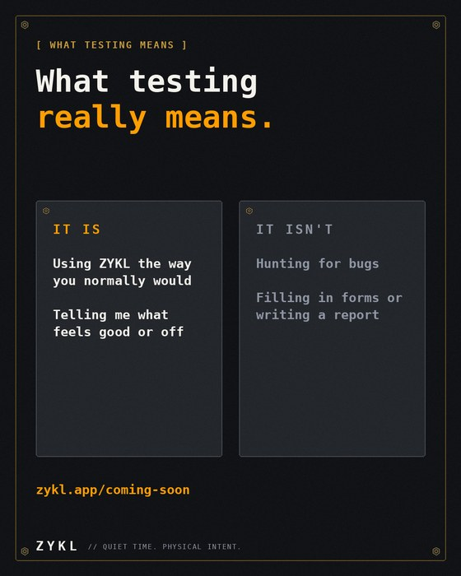  images/personal-active/en|id/w08_what_testing_means.png | Week 3, Sun | Gentle ask | Text + image  ENGLISH  What being a beta tester actually means:  It is: using ZYKL the way you normally would, and telling me what feels good or off.  It isn't: hunting for bugs, filling out forms, or writing a report.  If that sounds doable, I'd be grateful for your help: zykl.app/coming-soon  BAHASA INDONESIA  Apa arti menjadi penguji beta sebenarnya:  Yang dilakukan: memakai ZYKL seperti biasa, lalu bilang apa yang terasa enak atau janggal.  Bukan: berburu bug, mengisi formulir, atau menulis laporan.  Kalau itu terasa mudah, aku akan sangat berterima kasih atas bantuanmu: zykl.app/coming-soon  TIP  Lowers the effort people imagine, without any pressure.  EN 270 / ID 287 characters (limit 500)

Post 22: Build in public
TEXT ONLY | Week 4, Mon | Build in public | Text only  ENGLISH  How I decide what to build next on ZYKL:  1. Something a tester struggled with  2. Something that makes the app calmer  3. Something that makes it faster to start  If a feature does none of these, it waits. Short list, but it keeps me honest.  BAHASA INDONESIA  Cara aku memutuskan apa yang dibangun berikutnya di ZYKL:  1. Sesuatu yang membuat penguji kesulitan  2. Sesuatu yang membuat aplikasi lebih tenang  3. Sesuatu yang membuat lebih cepat mulai  Kalau sebuah fitur tidak memenuhi satu pun, ia menunggu. Daftarnya pendek, tapi menjagaku tetap jujur.  TIP  A draft process. Edit it to match how you actually decide.  EN 240 / ID 292 characters (limit 500)

Post 23: Focus tip
TEXT ONLY | Week 4, Tue | Focus tip | Text only  ENGLISH  Focus tip: 25 minutes isn't sacred.  Deep work like writing or coding may fit 50 minutes with a 10-minute break. Admin tasks may fit 15. Pick the length that matches the task, then keep it for a week before changing.  What's your focus length?  BAHASA INDONESIA  Tips fokus: 25 menit itu tidak keramat.  Pekerjaan mendalam seperti menulis atau coding mungkin cocok 50 menit dengan istirahat 10 menit. Tugas administratif mungkin cukup 15. Pilih durasi yang cocok dengan tugasnya, lalu pertahankan seminggu sebelum mengubah.  Berapa lama fokusmu?  TIP  ZYKL has 25/5, 50/10 and 15/3 presets plus a custom one, so this fits naturally.  EN 243 / ID 282 characters (limit 500)

Post 24: Builder question
TEXT ONLY | Week 4, Wed | Builder question | Text only  ENGLISH  New here? Welcome.  I'm Ricky, a solo founder from Indonesia building ZYKL, a calm focus timer for Android. I post build logs, focus tips and honest lessons.  Say hi in the replies: what do you do, and what are you working on?  BAHASA INDONESIA  Baru di sini? Selamat datang.  Aku Ricky, solo founder dari Indonesia yang membuat ZYKL, timer fokus yang tenang untuk Android. Aku memposting catatan build, tips fokus, dan pelajaran jujur.  Sapa di balasan: kamu kerja apa, dan lagi mengerjakan apa?  TIP  Your best 'start here' post, and the same shape as the hello post that worked. Consider pinning it.  EN 226 / ID 250 characters (limit 500)

Post 25: Design detail
TEXT ONLY | Week 4, Thu | Design detail | Text only  ENGLISH  Why ZYKL's tagline is 'Quiet Time. Physical Intent.'  Quiet, because a focus tool shouldn't make noise of its own. Physical, because deciding to focus is easier when you do something with your hand: turn a dial, stamp a slip.  Small rituals, big start.  BAHASA INDONESIA  Kenapa tagline ZYKL adalah 'Quiet Time. Physical Intent.'  Quiet, karena alat fokus tidak seharusnya membuat bising. Physical, karena memutuskan untuk fokus lebih mudah kalau tanganmu melakukan sesuatu: memutar dial, mencap slip.  Ritual kecil, awal yang besar.  TIP  Brand story in three lines.  EN 252 / ID 261 characters (limit 500)

Post 26: Founder story
TEXT ONLY | Week 4, Fri | Founder story | Text only  ENGLISH  Honest question for you: what makes you trust a new app from a solo founder?  A clear privacy stance? Real screenshots? Someone replying to every comment? I'm collecting answers, and I'll build on them.  Tell me what you look for.  BAHASA INDONESIA  Pertanyaan jujur untukmu: apa yang membuatmu percaya pada aplikasi baru dari solo founder?  Sikap privasi yang jelas? Screenshot asli? Orang yang membalas setiap komentar? Aku mengumpulkan jawaban, dan akan membangun dari situ.  Ceritakan apa yang kamu cari.  TIP  Free market research. Quote the best answers in a later post.  EN 230 / ID 258 characters (limit 500)

Post 27: Light and fun
POLL | Week 4, Sat | Light and fun | Text + poll  ENGLISH  Saturday poll: where do you focus best?  Vote below, and tell me your setup in the replies.  BAHASA INDONESIA  Poll Sabtu: di mana kamu paling bisa fokus?  Vote di bawah, dan ceritakan setup-mu di balasan.  POLL OPTIONS (25 CHARACTERS MAX EACH)  EN: Home desk / Cafe / Library / Bed (be honest)  ID: Meja di rumah / Kafe / Perpustakaan / Kasur (jujur ya)  TIP  Use the built-in poll.  EN 91 / ID 94 characters (limit 500)

Post 28: Gentle ask
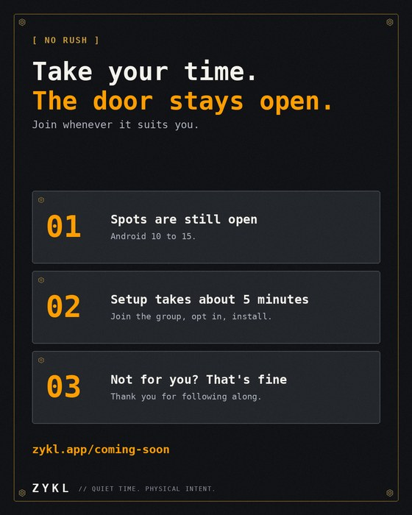  images/personal-active/en|id/w09_take_your_time.png | Week 4, Sun | Gentle ask | Text + image  ENGLISH  Still thinking about being a ZYKL tester? Take your time.  The spots are still open, setup takes about 5 minutes, and you can join whenever it suits you.  And if it's not for you, thank you for following along. That already means a lot.  zykl.app/coming-soon  BAHASA INDONESIA  Masih mempertimbangkan jadi penguji ZYKL? Santai saja.  Kursinya masih terbuka, setup sekitar 5 menit, dan kamu bisa bergabung kapan pun yang cocok untukmu.  Dan kalau ini bukan untukmu, terima kasih sudah mengikuti. Itu sudah berarti banyak.  zykl.app/coming-soon  TIP  Post only while spots are open. If they're full, thank everyone instead.  EN 258 / ID 264 characters (limit 500)

5. Fallback prompts for low-energy days
One line each. Post them as plain text, then reply to every answer.
# | English | Bahasa Indonesia
1 | One word for how your focus is today? | Satu kata untuk fokusmu hari ini?
2 | What's on your desk right now? Photo welcome. | Apa yang ada di mejamu sekarang? Foto boleh.
3 | Name an app that does one thing really well. | Sebutkan satu aplikasi yang melakukan satu hal dengan sangat baik.
4 | What did you finish today, however small? | Apa yang berhasil kamu selesaikan hari ini, sekecil apa pun?
5 | Coffee, tea, or water while you work? | Kopi, teh, atau air putih saat bekerja?
6 | What's the first thing you do when you sit down to focus? | Apa hal pertama yang kamu lakukan saat duduk untuk fokus?

6. Optional perks (only if you decide)
The tester posts above promise nothing except early access. If you decide to offer something more, these lines are ready to paste. Don't use them unless you'll deliver.
Perk idea | English line | Bahasa Indonesia
Free Studio PRO for testers | As a thank-you, every tester gets Studio PRO free. | Sebagai ucapan terima kasih, setiap penguji mendapat Studio PRO gratis.
A thank-you list (with permission) | Testers who agree will be thanked by name on the ZYKL site. | Penguji yang setuju akan diucapkan terima kasih dengan nama di situs ZYKL.
A voice in the roadmap | Testers get a say in what I build next. | Penguji punya suara dalam apa yang kubangun berikutnya.
Don't tie any perk to a store review. That can go against Google Play's rules. Ask for private feedback instead.

7. Rules and checklist
- Keep the tone warm. Say what you're doing and why, then leave the door open. Skip words like 'last chance', 'hurry' or 'must'.
- Only post a tester ask while spots are really open. If they're full, say thank you instead.
- Edit the draft lines about you (Posts 1, 3, 5, 10, 12, 22) until they're true.
- One topic tag per post. 'Solo founders startup' is already working for you, so keep testing it.
- Keep 'Braun' out of public text, don't name competitors, and don't claim 'no streaks'.
- Refresh numbers (Posts 8 and others) on the day you post.

